RZR XP900S STAGE 5 DUAL EXHAUST SYSTEM
INSTALLATION INSTRUCTIONS

Beginning with the muffler, completely remove the OEM exhaust system and rear lower right and left fairing support brackets . Place all OEM mounting hardware to the side, as a few components will be used during the installation of the Trinity Racing exhaust system.
Loosely Pre-assemble the mufflers with the supplied billet aluminum double mounting clamps as seen in (Fig. 1) but do not full tighten or install.Set to the side.
Next install the Muffler L Brackets using supplied hardware as seen in (Fig. 2). The side of bracket with welded nuts will point down for mufflers. Do not fully tighten at this point.
Next Install the Z support bracket using OEM hardware to the center hole as seen in (Fig 3). Do not fully tighten at this point.
Install the Trinity Supplied rear lower right and left fairing support brackets using OEM hardware. As seen in (Fig 4). Note that left and right brackets are different. Do not fully tighten.
Now mount the pre-assembled mufflers onto the previously installed L brackets and Z Brackets. (Fig 1)
Install the new exhaust dual headpipe manifold to the cylinder head using the OEM hardware. A new OEM exhaust gasket is recommended, though not required if your original gasket is in great condition. (Fig. 5).
Install the front side of the 2 into 1 collector onto the head pipes, making sure to install the collector with the Trinity logo facing right side up. Install the flared end of the mid pipes onto the rear portion of the collector, and slide the remaining portion of the mid pipes into the muffler inlets. (Fig. 6).
Complete the system by installing 2 springs between the front of the collector and the head pipes, 2 springs between the rear of the collector and the mid pipes, and 2 springs between the mid pipes and the muffler inlets (using supplied bolt on spring mounts).. Once all springs have been installed, torque all mounting hardware to OEM specifications. (All mounting hardware should be re-torqued following the first couple hours of riding.)
Reinstall rear plastic fairing. Before starting the vehicle, clean all stainless steel sections of the exhaust system with carb cleaner, brake cleaner, or stainless steel cleaner to remove all oil and finger prints from installation
WARNING
*Trinity Racing exhaust systems will require adjustment to OEM fuel settings such as jetting changes or installation of an EFI programmer. Trinity Racing will not be held responsible for damages that occur during operation of your vehicle under improper fuel settings. Ultimately, it is the responsibility of the owner/rider to adjust fuel settings to specific riding conditions and elevation changes before riding.

*Inspection of the muffler packing is recommended following every 15 hours of runtime. Failure to maintain muffler packing will result in power loss, increased sound output, and damage to the muffler body or muffler components.

*Trinity Racing exhausts systems are designed for high performance applications and are legal for closed course competition only. This product is not applicable nor intended for use on emissions controlled street, highway, or off-road vehicles.

Trinity Racing
9370 7th St, Suite B, Rancho Cucamonga CA 91730
909-987-4213 Tech Support

(FIG. 2)
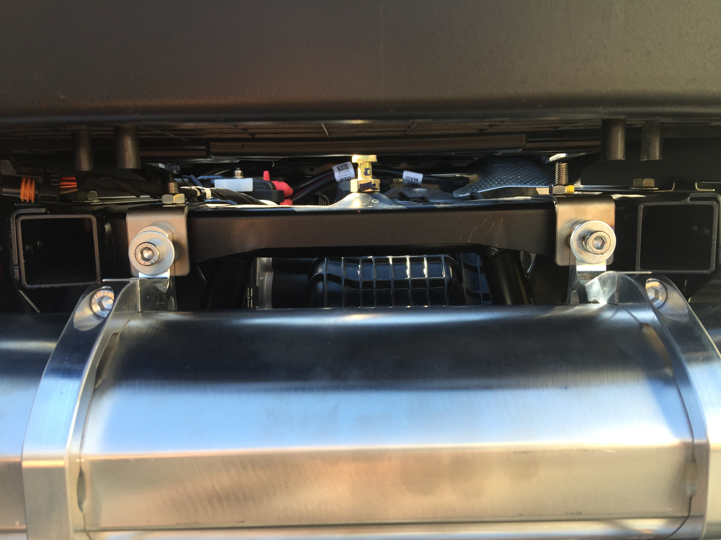

(FIG 3)
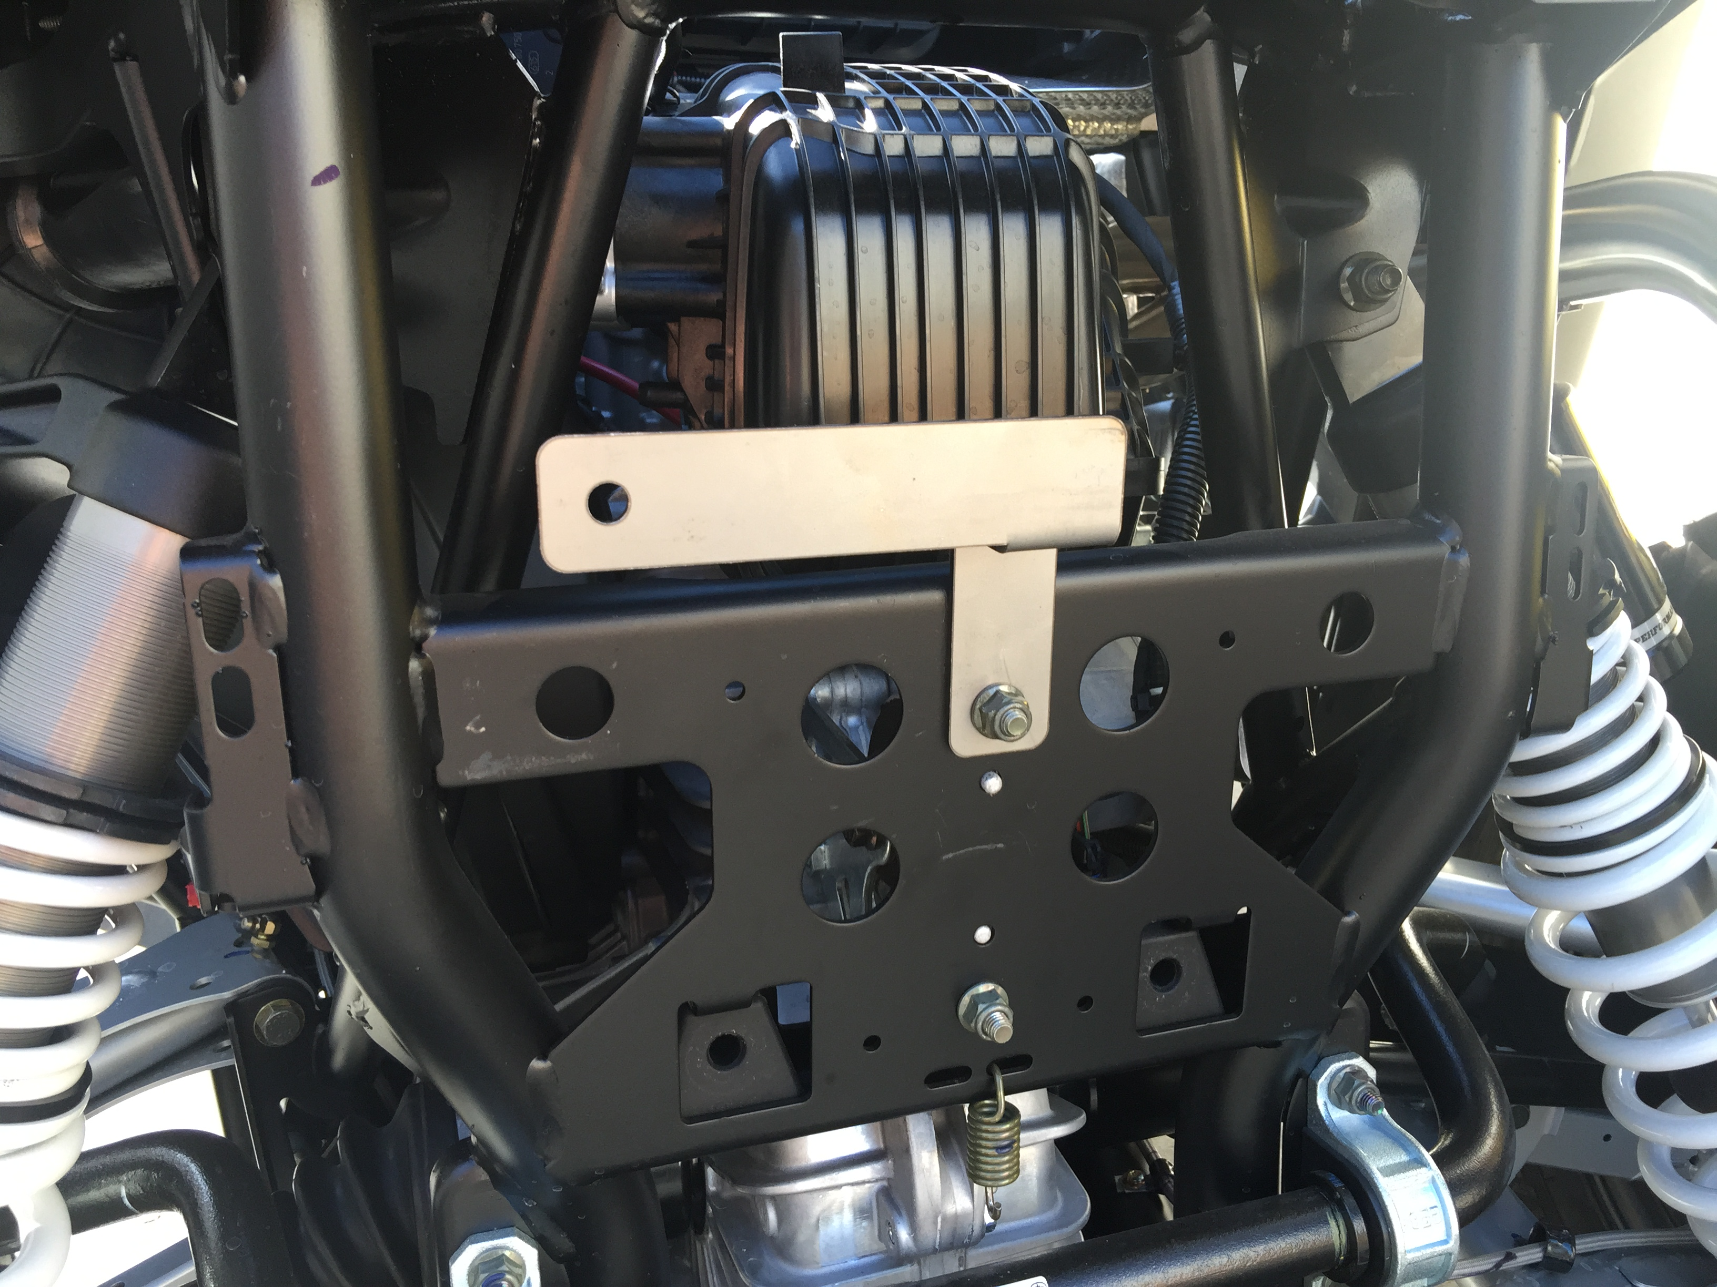

(FIG. 5)

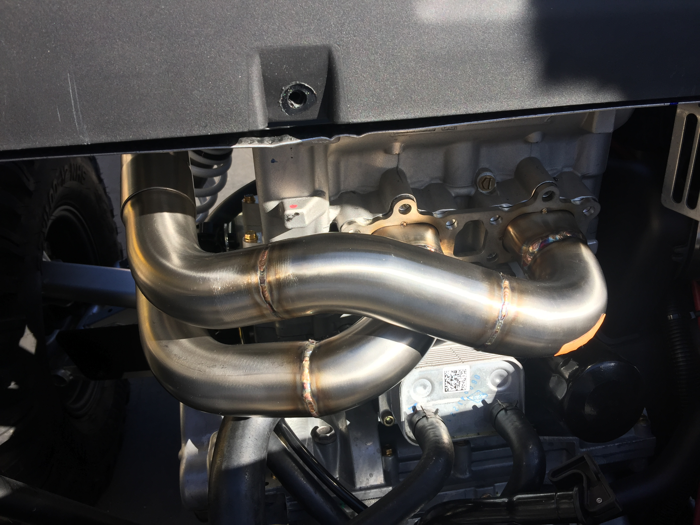

(FIG. 6)
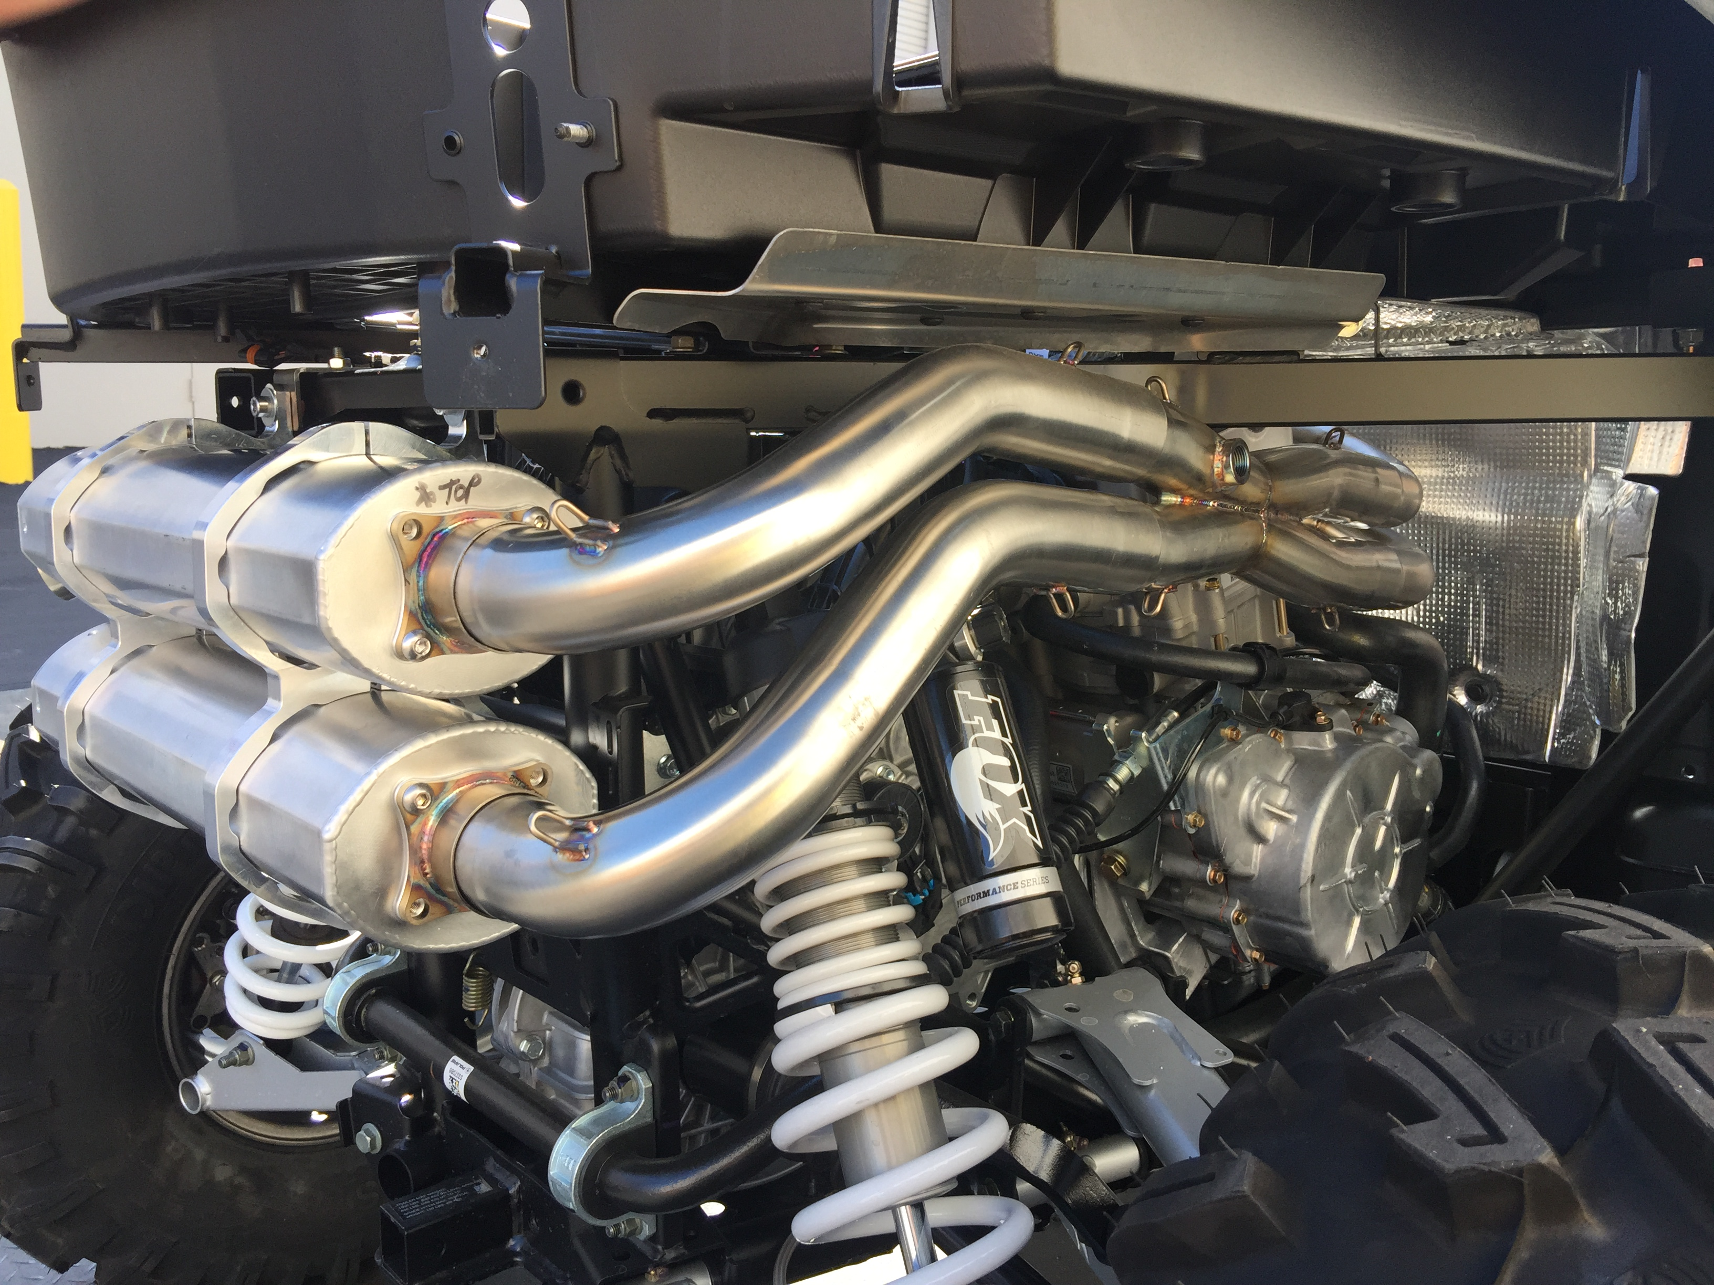

(FIG. 1)
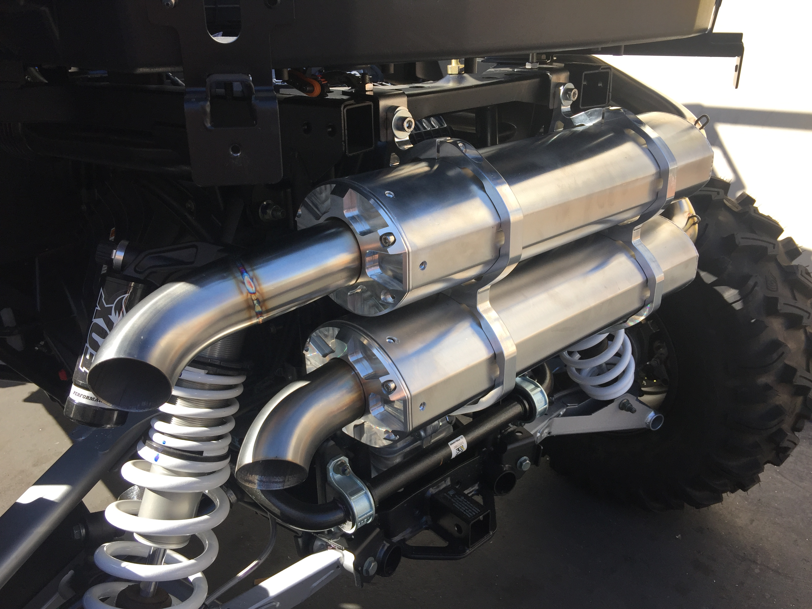

(FIG. 4)
